**Data Analysis and Visualization**

We visually analyzed our final data (Merge.csv) using Tableau and found the following initial conclusions –

1. **Item sales vs Time of the Year**

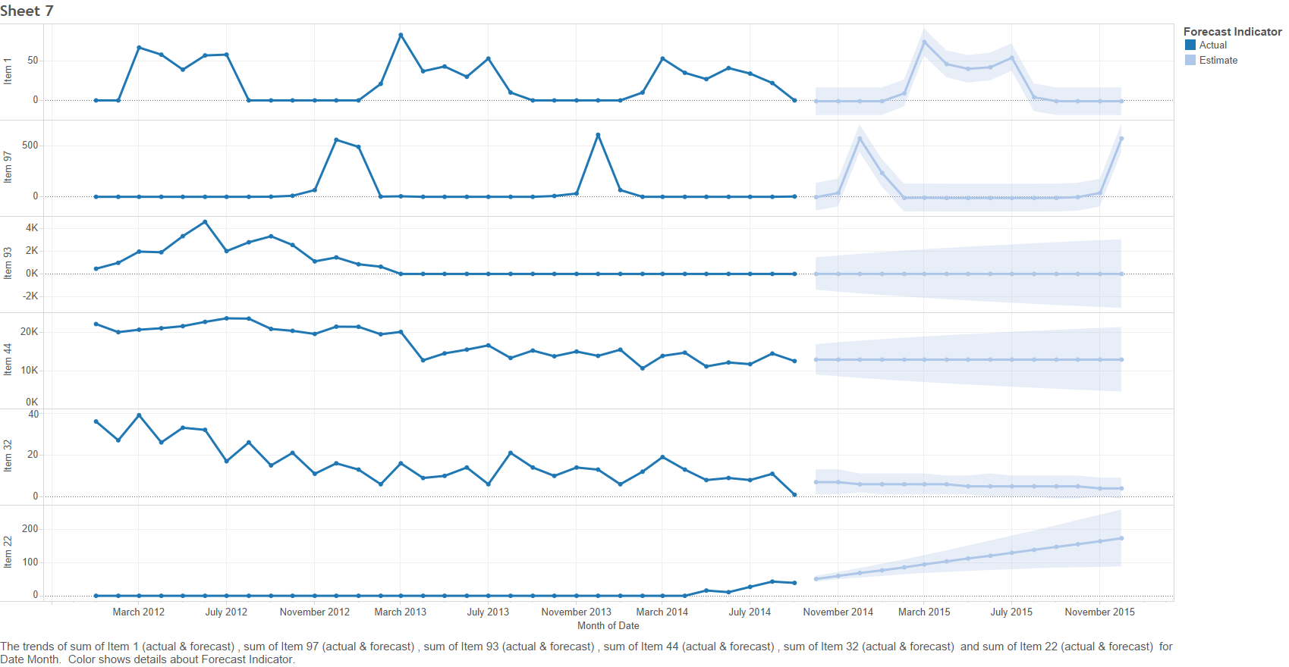

* As the above graph shows, the demand for items changes as per season and months thus the supply should adapt to such changes.
* Item1 and Item97 vary according to each month, Item1 being bought mostly during March-July and the latter from December to January. Whereas Items 44 and 32 are fairly constant over the months.
* We also see that Item93 hasn’t been sold post-March 2013 and would likely be not sold.

As opposed to Item22 which has just started its sales from April 2014.

* There are predictions shown at the right in light color, as to how the sales would be.

1. **Effect of Thunderstorms on Item Sales -**

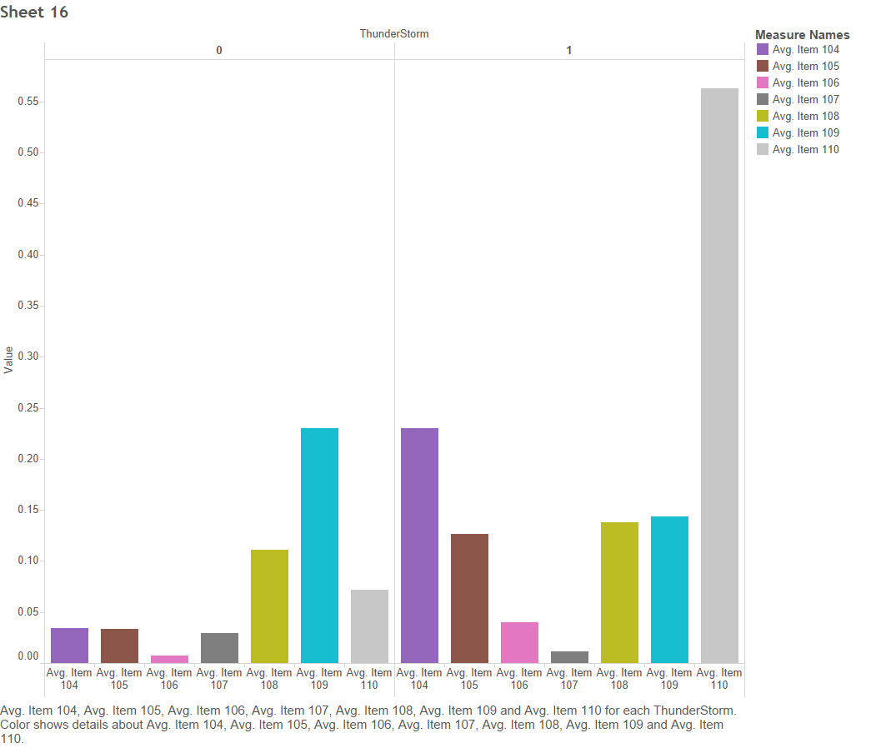

* The sale of some of the items spike while others reduce. More no. of Item110 are sold during the storm. Whereas, Item109 is sold less during the thunderstorms.